

“SMART PARKING SPACE DETECTION”
A CAPSTONE PROJECT REPORT
A Capstone Project Report submitted in partial fulfilment of the requirements
for the Course of
ITA0515 – Computer vision
to the award of the degree of
BACHELOR OF ENGINEERING / BACHELOR OF TECHNOLOGY IN
COMPUTER SCIENCE AND ENGINEERING (ARTIFICIAL INTELLIGENCE)
Submitted by
192425088 -KARRI HEMAKSHITHA
192425248-KORLAKUNTA SREELATHA
192425366-AMRUTHA K
192472036-ALURU VENKATA AMEYA

Under the Supervision of
Dr.M.J. Carmel Mary Belinda

SIMATS ENGINEERING
Saveetha Institute of Medical and Technical Sciences
Chennai-602105
SEPTEMBER 2026

SIMATS ENGINEERING
Saveetha Institute of Medical and Technical Sciences
Chennai-602105
BONAFIDE CERTIFICATE
This is to certify that the Capstone Project entitled “Smart Parking Space Detection” has been carried out A.V.Ameya-192472036,K.Hema-192425088,K.SreeLatha-192425248,K.Amrutha -192425366 under the supervision of Dr.Caramel Mary Balinda and is submitted in partial fulfilment of the requirements for the current semester of the B.Tech Computer Science and Engineering (Artificial Intelligence) program at Saveetha Institute of Medical and Technical Sciences, Chennai.
COURSE COORDINATOR | COURSE FACULTY
Dr Gunasekaran , Dr Rashmitha  AI & ML , CSE - AI  Department of AI & ML , CSE-AI  SIMATS Engineering, Chennai – 602105. | Dr Carmel Mary Belinda  CSE  Department of Computer Science and Engineering  SIMATS Engineering, Chennai – 602105.

SIMATS ENGINEERING
Saveetha Institute of Medical and Technical Sciences
Chennai-602105
DECLARATION
We, A.V.Ameya-192472036,K.Hema-192425088,K.Sree Latha-192425248,K.Amrutha -192425366 of the Department of Computer Science and Engineering, SIMATS Engineering, Saveetha Institute of Medical and Technical Sciences, Chennai, hereby declare that the Capstone Project Work entitled “Smart Parking Space Detection” is the result of our own bonafide efforts. To the best of our knowledge, the work presented herein is original, accurate, and has been carried out in accordance with the principles of engineering ethics and academic integrity. All sources, references, data, and other materials used in the project have been appropriately acknowledged. We further declare that the data, results, analysis, and findings presented in this report have not been fabricated, falsified, or manipulated. Any external tools, software, datasets, computational resources, or AI-assisted tools used during the project have been appropriately disclosed. We confirm that all applicable ethical, academic, institutional, and professional requirements have been duly followed throughout the planning, execution, analysis, and documentation of the project.
Place: Chennai
Date: 5/09/2026

Signature of the Students with Names
192425088 -KARRI HEMAKSHITHA
192425248-KORLAKUNTA SREELATHA
192425366-AMRUTHA K
192472036-ALURU VENKATA AMEYA

SIMATS ENGINEERING
Saveetha Institute of Medical and Technical Sciences
Chennai-602105
Individual Contribution Statement
(Mandatory for all team projects)
Student Name / Reg. No. | Specific Responsibilities | Design & Development Contribution | Testing & Analysis Contribution | Report Contribution | Approx. Contribution (%)
A.V.Ameya | Requirement analysis, parking-space ROI mapping and Module 1 – Parking Space Detection and Occupancy Analysis | Designed and implemented parking-space detection, ROI extraction and occupancy analysis | Tested parking-space detection and occupancy classification | Contributed to Chapters 1, 2 and Module 1 documentation | 25%
K.Amrutha | Module 2 – Parking Status Display and Alert | Designed and implemented colour-coded status display, free/occupied counts and parking-full alert | Tested status display, counting and alert conditions | Contributed to Module 2 documentation and Chapter 4 | 25%
K Hema | Module 3 – Testing and Evaluation | Designed test cases and evaluation procedure for different parking scenarios | Performed module testing, integration testing and analysed expected results | Contributed to testing, results and evaluation sections | 25%
K Sreelatha | Module 4 – Documentation and Project Integration | Coordinated integration of modules and supported overall system documentation | Verified integrated system workflow and reviewed final outputs | Prepared/compiled report sections, references and final documentation | 25%

Total Contribution: 100%

ABSTRACT
Locating a vacant parking space in busy urban areas, campuses, and commercial complexes is a recurring problem that wastes commuter time, increases fuel consumption, and adds to traffic congestion near entry points. Most existing parking facilities still rely on manual observation or simple boom-barrier counters that do not indicate which specific space is free, forcing drivers to search row by row. This project, “Smart Parking Space Detection”, addresses this engineering problem by developing a computer-vision-based system that automatically determines the occupancy status of individual, predefined parking spaces from a camera image or video feed and presents this information through an easy-to-read visual display. The system is organised into two main modules. Module 1, the Parking Space Detection and Occupancy Analysis module, acquires an image or video frame, pre-processes it, isolates the predefined parking-space regions, and analyses each region to determine whether a vehicle is present. Module 2, the Parking Status Display and Alert module, renders the outcome of this analysis using a simple colour code — green for a free space and red for an occupied space — and additionally computes and displays the total, free, and occupied space counts, raising a “PARKING FULL” alert when no free space remains.
The methodology combines classical image-processing techniques (grayscale conversion, noise reduction, and region-of-interest extraction) with an occupancy classifier, implemented in Python using OpenCV and NumPy, with an optional deep-learning-based vehicle detector considered as an extension. The system was designed and evaluated using representative parking-lot images and video clips, and its behaviour was verified against a structured set of test cases covering free spaces, occupied spaces, mixed occupancy, and full-parking conditions. The project demonstrates that a camera-based, software-only approach can provide a low-cost, scalable, and easily deployable alternative to sensor-per-slot hardware installations, and it identifies clear directions for future enhancement, including robustness to lighting variation and integration with mobile or web dashboards.
Keywords
Smart Parking, Computer Vision, OpenCV, Occupancy Detection, Image Processing, Object Detection.

TABLE OF CONTENTS
Sl. No. | Title | Page No.
i | BONAFIDE CERTIFICATE | 2
ii | DECLARATION BY THE CANDIDATE | 3
iii | INDIVIDUAL CONTRIBUTION STATEMENT | 4
iv | ABSTRACT | 5
v | LIST OF FIGURES | 6
vi | LIST OF TABLES | 7
vii | LIST OF ABBREVIATIONS | 8
1 | CHAPTER 1: Introduction and Engineering Problem | 10-12
2 | CHAPTER 2: Literature Review and Existing Solutions | 13-15
3 | CHAPTER 3: Engineering Design & Trade-offs, Sustainability, Ethics, Safety, Risk & Security | 16-21
4 | CHAPTER 4: Implementation, Testing & Results, Project Management | 22-26
5 | CHAPTER 5: Conclusion, Future Work and Reflection | 27-29
 | References | 30
 | Appendices | 31-32

LIST OF FIGURES
Figure No. | Figure Name | Page No.
3.1 | Two-Module System Architecture | 18
3.2 | System Flow of Smart Parking Space Detection | 19
4.1 | Sample Parking Status Visualization (Illustrative Mock-up) | 23

LIST OF TABLES
Table No. | Table Name | Page No.
2.1 | Summary of Reviewed Literature | 13
2.2 | Comparative Analysis of Existing Approaches | 13
3.1 | Stakeholder / User Requirements | 16
3.2 | Functional & Non-Functional Requirements | 16
3.3 | Constraints & Applicable Standards | 17
3.4 | Design Specifications | 17
3.5 | Evaluation of Alternative Solutions | 18
3.6 | Trade-off Analysis | 20
3.7 | Sustainability, Ethics, Safety, Risk & Security | 20
3.8 | Risk Register | 21
4.1 | Tools / Software Used | 22
4.2 | Test Plan & Verification | 22
4.3 | Comparison with Existing Solutions & Achievement of Objectives | 23
4.4 | Project Roles and Responsibilities | 24
4.5 | Estimated Project Budget | 24

LIST OF ABBREVIATIONS / SYMBOLS
Symbol | Description | Unit
CV | Computer Vision | -
CNN | Convolutional Neural Network | -
ROI | Region of Interest | -
FPS | Frames Per Second | fps
RGB | Red-Green-Blue (colour image format) | -
YOLO | You Only Look Once (object detector) | -
API | Application Programming Interface | -
UI | User Interface | -

CHAPTER 1
INTRODUCTION AND ENGINEERING PROBLEM
1.1 Background
The rapid growth of vehicle ownership in urban areas, educational campuses, and commercial complexes has made the search for an available parking space a routine source of delay and frustration. In most existing facilities, drivers must visually scan multiple rows or drive slowly through a parking lot to locate a free bay, which increases fuel consumption, congestion near entrances, and the likelihood of minor collisions. Traditional parking-management solutions either rely on manual attendants or on per-slot hardware sensors (ultrasonic, infrared, or magnetic loop sensors) that report only a binary occupied/free state and require substantial wiring and maintenance for every individual space.
Computer vision offers an attractive alternative: a single fixed camera overlooking a row or an entire lot can, in principle, monitor many parking spaces simultaneously without any per-slot hardware. Advances in image processing and, more recently, deep-learning-based object detection have made it practical to analyse a camera frame and determine which regions of a parking area are occupied by vehicles. This project, “Smart Parking Space Detection”, explores this camera-based approach and builds a working software prototype that detects the occupancy of predefined parking spaces from an image or video input and communicates the result through a simple, colour-coded visual display.
1.2 Need for the Project
The need for the project can be explained through the following points:
- Manually checking parking availability is time-consuming for drivers and inefficient for facility operators, particularly during peak hours.
- Drivers unfamiliar with a parking area (visitors, students, customers) are most affected, as they have no prior knowledge of which rows are usually full.
- Sensor-per-slot systems are accurate but expensive to install and maintain at scale, since every space requires its own hardware unit and wiring.
- A vision-based system uses commodity cameras that are already installed for surveillance in many facilities, so it can add occupancy detection as a software layer with comparatively low incremental cost.
- From an engineering standpoint, there is a genuine need for a system that combines image acquisition, pre-processing, region-wise occupancy analysis, and a clear status display into a single coherent pipeline.
1.3 Problem Statement
Given a camera image or video feed of a parking area containing a set of predefined parking spaces, the problem is to automatically and reliably determine, for each individual space, whether it is free or occupied, and to present the aggregated status (per-space status, total spaces, free spaces, occupied spaces, and a full-parking condition) in a clear visual form. The problem is technically non-trivial because it must handle multiple interacting factors simultaneously: variation in lighting and shadows across the day, partial occlusion of parking-space boundaries by adjacent vehicles, differences in vehicle size and orientation, and the conflicting requirement of keeping the processing pipeline simple and low-cost while still producing dependable occupancy decisions across these varying conditions.
1.4 Project
The aim of this project is to develop a computer-vision-based smart parking system that automatically detects parking-space occupancy from image or video input and clearly displays parking availability using a simple, intuitive visual representation.
1.5 Project Objectives
- To design a two-module system architecture separating occupancy detection from status display and alerting.
- To develop an image-processing pipeline that identifies predefined parking-space regions and analyses them for vehicle presence.
- To implement a free/occupied classification method for each individual parking space using image or video frames.
- To implement a visual status-display module that marks free spaces in green and occupied spaces in red, and computes total, free, and occupied space counts.
- To test the system against a structured set of test cases and evaluate its behaviour under representative parking scenarios, including a full-parking condition.
1.6 Scope
What is included:
- Detection of occupancy status (free/occupied) for a set of predefined, fixed parking spaces from a single camera's image or video input.
- A two-module pipeline: occupancy detection and analysis (Module 1) and status display with counting and full-parking alert (Module 2).
- A colour-coded visual output (green = free, red = occupied) together with numerical availability counts.
What is excluded:
- Automatic number-plate recognition, vehicle identification, or driver billing/payment integration.
- Multi-camera sensor fusion across an entire multi-storey facility.
- A production mobile application or cloud deployment; the prototype is demonstrated as a desktop/local application.
- Guaranteed real-time performance figures, since the project has not been subjected to large-scale, continuous field trials.
Assumptions and boundary conditions:
- The camera position and the boundaries of each parking space are known or can be configured/calibrated in advance.
- Parking spaces are demarcated (painted lines or a known fixed layout) so that region-of-interest mapping is possible.
- Lighting is sufficient for the camera to distinguish a vehicle from the empty road/ground surface; extreme darkness or heavy fog is outside the tested scope.
1.7 Expected Engineering Outcome
The expected outcome of this capstone project is a working software prototype (a Python-based computer-vision application) that: (a) accepts an image or video of a parking area, (b) identifies the predefined parking-space regions, (c) classifies each region as free or occupied, and (d) displays the result as a colour-coded overlay together with availability counts and a full-parking alert where applicable. The deliverable is a system/algorithmic prototype rather than a physical hardware product, since the project is centred on an image-processing and computer-vision pipeline implemented entirely in software.

CHAPTER 2
LITERATURE REVIEW AND EXISTING SOLUTIONS
2.1 Review Method
Author(s) | Year | Title | Main Purpose | Method | Key Finding | Limitation | Relevance to This Project
Amato, G. et al. | 2017 | Deep learning for decentralized parking lot occupancy detection | To classify individual parking-space patches as occupied/vacant using a lightweight CNN suitable for on-camera (edge) deployment | Trained a compact CNN (mAlexNet) on labelled patches from the CNRPark-EXT dataset, collected across seasons and viewpoints | Decentralised CNN inference achieved high classification accuracy while remaining light enough for smart cameras with limited resources | Performance degrades under severe occlusion and very oblique camera angles not well represented in training data | Confirms that a per-slot patch classification approach (used in Module 1 of this project) is a practical, low-resource strategy
Almeida, P. et al. | 2015 | PKLot: A robust dataset for parking lot classification | To provide a large, labelled, multi-weather parking-lot image dataset for benchmarking occupancy classifiers | Collected and annotated over 12,000 parking-space images under sunny, cloudy, and rainy conditions from multiple camera viewpoints | Established that classifier accuracy is strongly influenced by weather and camera viewpoint variation, motivating diverse training data | Dataset is limited to the specific lots and camera positions used for collection, limiting direct transfer to unseen layouts | Supports the design decision to test this project's pipeline under varied lighting/shadow conditions rather than a single ideal case
Valipour, S. et al. | 2016 | Parking-stall vacancy indicator system using deep convolutional neural networks | To detect vacant parking stalls in real time using a CNN operating on cropped stall images from a single camera | Manually defined stall regions of interest and applied a CNN classifier to each cropped region per frame | Demonstrated that a single overhead/side camera with per-stall ROI cropping can reliably indicate vacancy without dedicated sensors | Requires manual, one-time definition of stall boundaries for each new camera position, which does not adapt automatically to camera movement | Directly supports this project's ROI-based, per-space classification design used in Module 1
Ren, S., He, K., Girshick, R., and Sun, J. | 2015 | Faster R-CNN: Towards real-time object detection with region proposal networks | To propose a unified deep-learning architecture for accurate, near-real-time general-purpose object detection | Combined a region-proposal network with a convolutional detection network sharing features for end-to-end training | Achieved significant gains in detection accuracy and speed over earlier region-based detectors, becoming a widely used baseline | Computationally heavier than lightweight classifiers, making it less suited to low-cost embedded deployment without a GPU | Considered as a possible vehicle-detector alternative for future, detector-based enhancement of this project
Redmon, J. and Farhadi, A. | 2018 | YOLOv3: An incremental improvement | To improve the speed–accuracy trade-off of single-stage object detectors for real-time applications | Proposed a single convolutional network that predicts bounding boxes and class probabilities directly from full images in one pass | Delivered competitive accuracy at substantially higher inference speed than two-stage detectors, suitable for near-real-time use | Detection accuracy for small or heavily overlapping objects is lower than that of slower, two-stage detectors | Identified as a candidate lightweight vehicle detector for a future, detection-based version of Module 1
Relevant literature was identified through keyword searches on Google Scholar, IEEE Xplore, and ResearchGate using search terms such as “smart parking occupancy detection”, “computer vision parking lot”, “CNN vehicle detection parking”, and “parking space classification deep learning”, focusing on peer-reviewed papers and widely cited conference/journal articles published between 2015 and 2018 that specifically addressed camera-based parking occupancy detection. Preference was given to studies that used publicly available datasets (such as PKLot and CNRPark-EXT) so that reported findings could be cross-checked against other work using the same data.
2.2 Review of Existing Work
Table 2.1 summarises five studies that are directly relevant to the design of this project. All five works approach parking occupancy detection using a camera-based, per-space classification or detection strategy rather than physical per-slot sensors, which aligns with the design direction chosen for this project.
Table 2.1: Summary of Reviewed Literature
2.3 Comparative Analysis
Existing Approach | Advantages | Limitations | Relevance to Proposed Work
Per-slot hardware sensors (ultrasonic/magnetic) | High per-slot accuracy; not affected by lighting or camera angle | Expensive to install and wire for every space; requires ongoing maintenance | Confirms the case for a camera-based alternative that avoids per-slot hardware
CNN-based patch classification (Amato et al., Valipour et al.) | Works with a single camera; scalable to many spaces at once; moderate computational cost | Sensitive to occlusion and requires initial ROI/stall definition | Directly informs the ROI-based occupancy-analysis design of Module 1
General-purpose object detectors (Faster R-CNN, YOLOv3) | Detect vehicles without manual per-slot ROI training; can generalise across layouts | Higher computational demand; may need a GPU for near-real-time speed | Identified as a future enhancement path for Module 1 rather than the baseline implementation
2.4 Research / Engineering Gap
The reviewed literature shows that reliable camera-based occupancy detection is achievable, but most published systems assume a fixed, well-calibrated single camera and report accuracy on curated benchmark datasets rather than in an end-to-end application that also communicates the result to an end user. There remains a gap between a standalone occupancy classifier and a complete, usable system that additionally performs region mapping, live status visualisation (colour-coded per space), availability counting, and a full-parking alert as a single, coherent pipeline suitable for demonstration on ordinary hardware.
2.5 Proposed Contribution
This project contributes an integrated, two-module pipeline that combines (i) a parking-space detection and occupancy-analysis module, built on classical image-processing steps together with a per-space occupancy classifier as informed by the reviewed CNN-based approaches, and (ii) a status-display and alert module that renders the analysis outcome as an intuitive green/red visual overlay, computes availability counts, and raises a full-parking alert. Unlike the reviewed works, which primarily report classifier-level accuracy, this project emphasises the complete detection-to-display pipeline in a form that is simple enough to explain and demonstrate for a B.Tech capstone project.

CHAPTER 3
ENGINEERING DESIGN & TRADE-OFFS, SUSTAINABILITY, ETHICS, SAFETY, RISK & SECURITY
3.1 Requirements
Stakeholder / User Requirements
Stakeholder | Requirement
Facility user / driver | Needs a quick, clear indication of which parking spaces are free before entering the lot
Facility operator / manager | Needs an accurate count of free and occupied spaces to manage capacity and reduce congestion
System developer / maintainer | Needs a modular, understandable pipeline that can be configured for a new camera position with minimal effort

Functional & Non-Functional Requirements
Requirement | Type (Functional/Non-Functional) | Measurable Target
Detect occupancy status of each predefined parking space | Functional | Correct free/occupied classification for all defined spaces in a test frame
Display free spaces in green and occupied spaces in red | Functional | Every displayed space is colour-coded consistently with its detected status
Compute total, free, and occupied space counts | Functional | Displayed counts match the number of spaces classified in each category
Raise a “PARKING FULL” alert when free spaces = 0 | Functional | Alert is shown only when the free-space count is exactly zero
Process a single image/frame within a reasonable time for demonstration | Non-Functional | Processing completes within a few seconds per frame on a standard laptop
Be configurable for a new camera view without code changes | Non-Functional | Parking-space ROI coordinates are stored in an editable configuration file
3.2 Constraints & Applicable Standards
Standard / Code | Requirement | How Applied in This Project
IEEE referencing style | Consistent citation of literature and technical sources | All references in Chapter/References section follow IEEE numbering style
Institutional data-privacy guidance | Captured images/video of public areas must not be misused or stored without purpose | Only parking-area regions are analysed; no personal or vehicle-identifying data is extracted or stored
General software engineering good practice (modular design) | Code should be organised into clearly separated, testable modules | The system is structured into two independent modules (detection/analysis and display/alert) with a defined interface between them
3.3 Design Specifications
Parameter | Target/Requirement | Unit | Priority
Input frame resolution | 640 x 480 (minimum recommended) | pixels | High
Number of predefined parking spaces supported | Configurable, demonstrated with 10-30 spaces | count | High
Per-frame processing time (prototype, CPU only) | Within a few seconds | seconds | Medium
Colour-coding consistency | 100% consistent with detected status | - | High
Configuration effort for a new camera view | Edit ROI coordinates in a configuration file | - | Medium
3.4 Alternative Solutions & Evaluation
Alternative 1 (Sensor-based): Install an ultrasonic or magnetic sensor at every individual parking space to directly detect vehicle presence and transmit status wirelessly to a central controller. Alternative 2 (Pure classical image processing): Use background subtraction and edge/contour analysis on each parking-space ROI without any learned classifier, relying entirely on hand-crafted rules to decide occupancy. Alternative 3 (Camera + classifier, selected approach): Use a single fixed camera together with ROI-based occupancy analysis informed by a lightweight classifier, as adopted by this project.
Criterion | Weight | Alternative 1 (Sensors) | Alternative 2 (Pure Classical CV) | Alternative 3 (Camera + Classifier)
Performance (accuracy) | 30% | High | Moderate (sensitive to lighting/shadows) | High
Cost | 25% | Low (expensive at scale) | High (only a camera needed) | High (only a camera needed)
Safety | 15% | High | High | High
Sustainability (scalability, maintenance) | 15% | Low (per-slot hardware maintenance) | High | High
Reliability across conditions | 15% | High | Low-Moderate | Moderate-High
3.5 Selected Design & Detailed Design
Alternative 3 was selected because it offers the best balance of cost, scalability, and reliability for the scope of this capstone project: a single camera avoids the wiring and maintenance overhead of per-slot sensors, while combining classical pre-processing with an occupancy classifier mitigates the reliability weaknesses of a purely rule-based approach. The selected design follows a two-module architecture, illustrated in Figure 3.1, and an end-to-end processing sequence, illustrated in Figure 3.2.
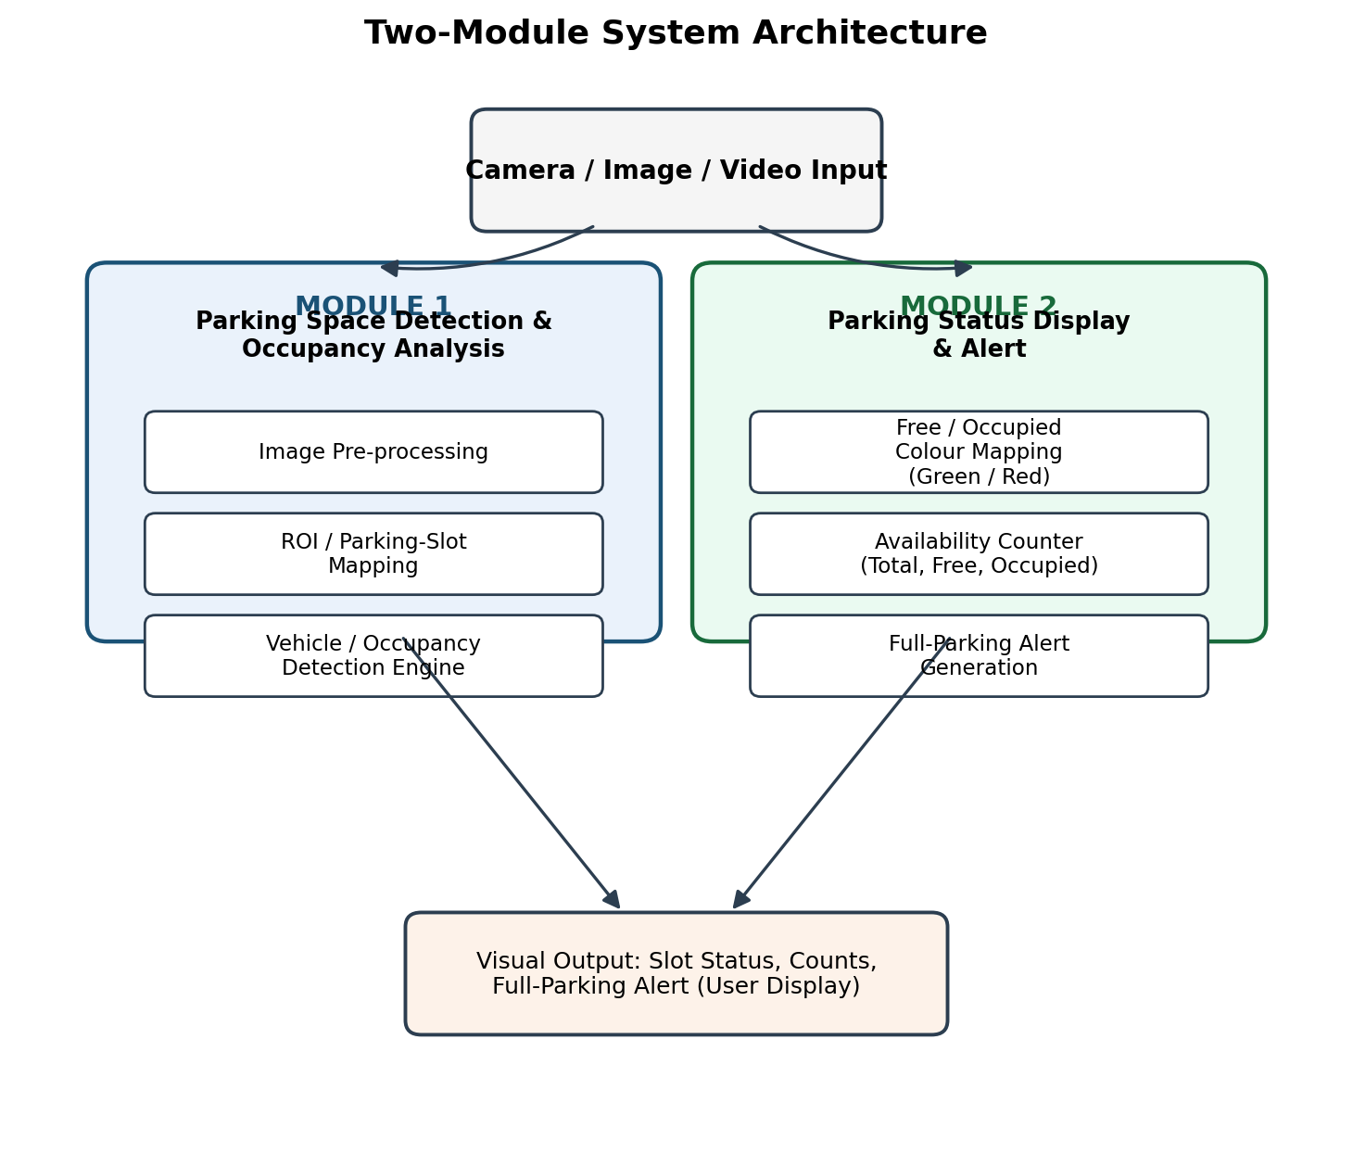
Figure 3.1: Two-Module System Architecture
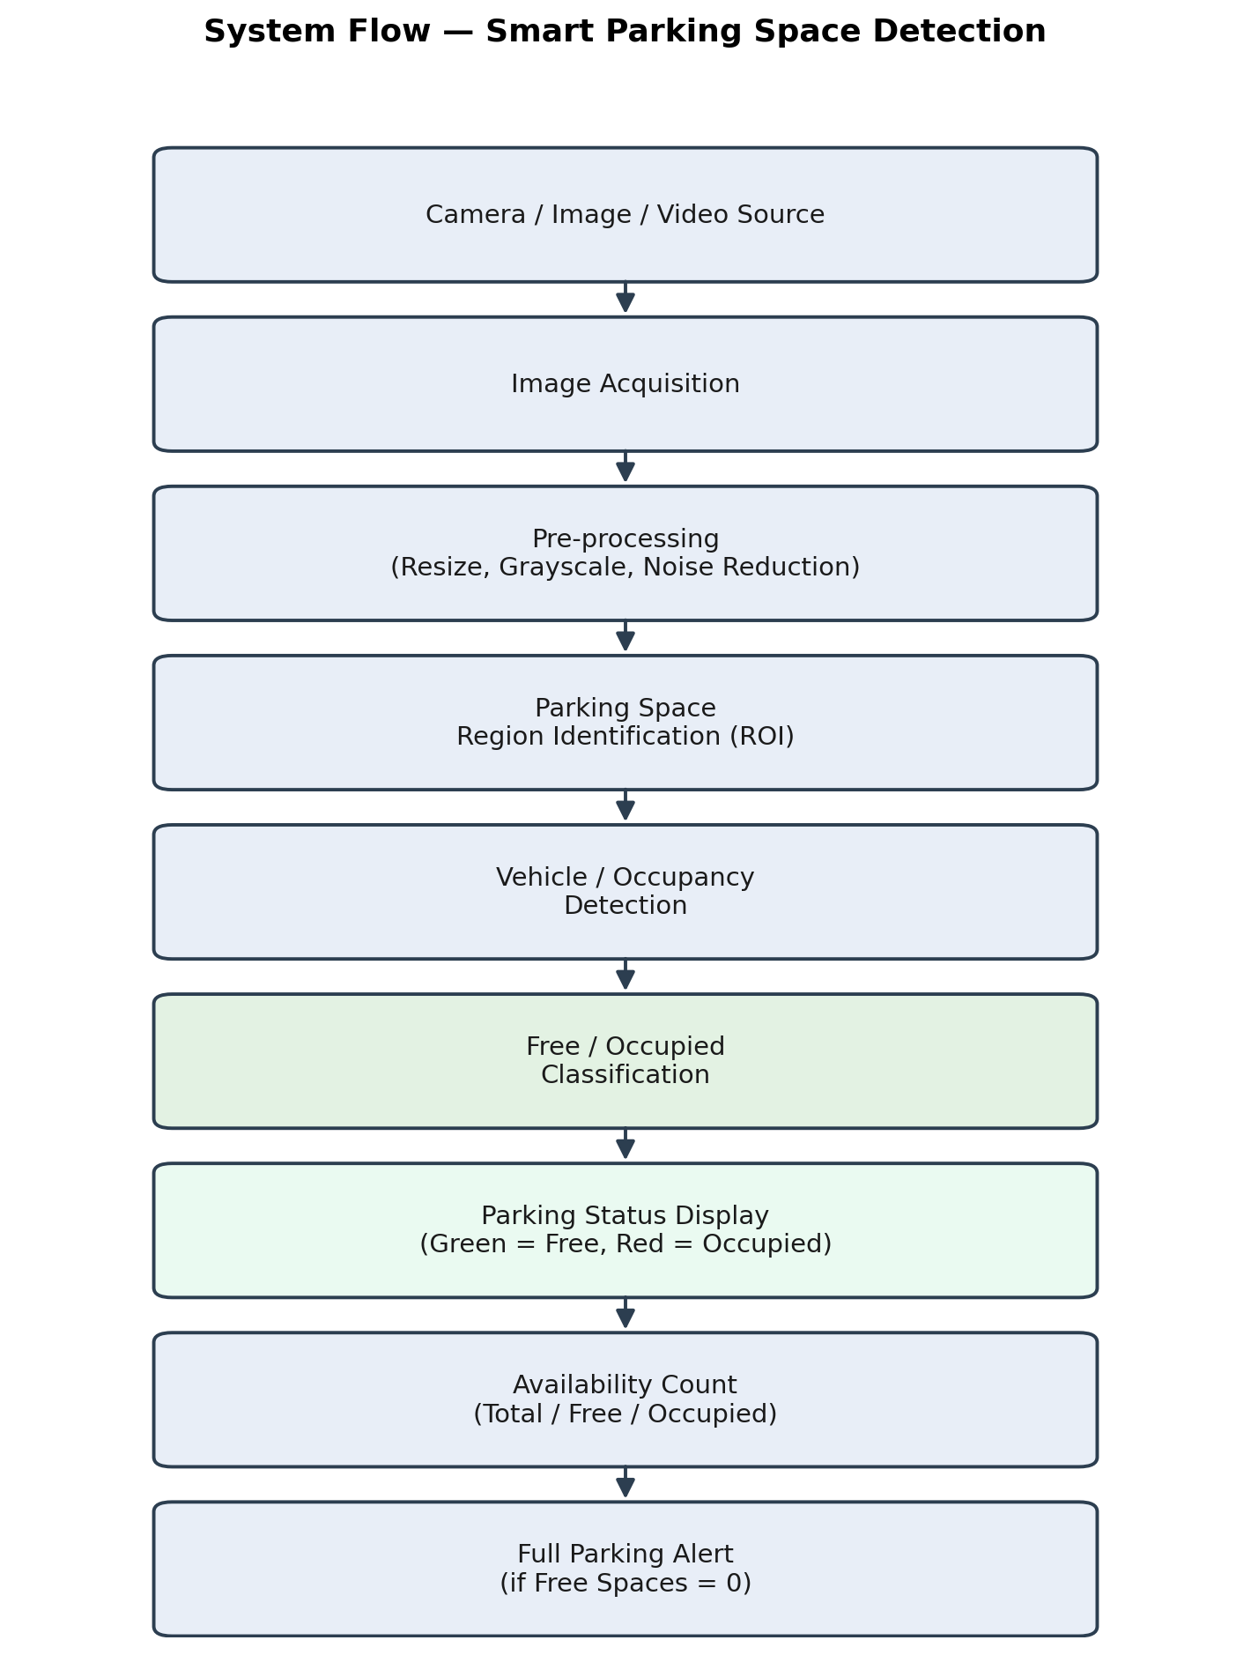
Figure 3.2: System Flow of Smart Parking Space Detection
Module 1 (Parking Space Detection and Occupancy Analysis) receives the camera image or video frame, applies pre-processing (resizing, grayscale conversion, and noise reduction), extracts the predefined parking-space regions of interest, and analyses each region to classify it as free or occupied. Module 2 (Parking Status Display and Alert) consumes the per-space classification produced by Module 1, maps each result to a colour (green for free, red for occupied), aggregates the counts (total, free, occupied), and raises a full-parking alert when the free-space count reaches zero.
Systems approach: Module 1 and Module 2 interface through a simple, well-defined data structure — a list of parking-space identifiers together with their free/occupied status — so that either module can be modified or replaced independently (for example, upgrading the classifier in Module 1, or changing the display style in Module 2) without requiring changes to the other module. This separation of concerns keeps the two subsystems loosely coupled while allowing them to operate together as a single pipeline.
3.6 Trade-off Analysis
Design Decision | Alternative Considered | Benefit | Disadvantage | Final Decision & Justification
Occupancy detection method | Per-slot hardware sensors | Very high per-slot accuracy | High installation/maintenance cost | Camera + ROI classification chosen for lower cost and easier scaling to more spaces
Detection algorithm complexity | Full deep-learning object detector (e.g., YOLOv3) | Potentially higher accuracy under varied conditions | Higher computational cost, harder to explain in viva | Lightweight classical + classifier pipeline chosen for the prototype; deep-learning detector noted as future work
Camera configuration | Automatic camera-angle calibration | No manual setup needed for new views | Significantly higher implementation complexity | Manual, one-time ROI configuration chosen to keep the prototype scope realistic
3.7 Sustainability, Ethics, Safety, Risk & Security
Domain | Consideration | Evidence Evaluated | Impact on Final Decision
Sustainability | Reduces fuel wasted while searching for parking, lowering emissions from idling/circling vehicles | Comparison of sensor-per-slot vs. single-camera hardware footprint | Favoured the camera-based approach, which needs far less physical hardware per space
Ethics | Captured footage of a parking area may incidentally include people or vehicle number plates | Review of what the system actually needs to extract (occupancy only, not identity) | Design restricts analysis to occupancy status only; no identity or number-plate data is processed or stored
Health & Safety | Camera installation should not obstruct driver sightlines or create a physical hazard | General placement guidelines for surveillance-style cameras | Recommended mounting positions are noted as an installation guideline, not part of the software scope
Security | Video/image data could be misused if stored insecurely or accessed without authorisation | Review of data-handling practices for the prototype | Prototype processes frames in memory for demonstration and does not persist raw video; production deployment would require access control and encrypted storage

Risk Register
Risk | Likelihood | Severity | Risk Level | Mitigation | Residual Risk
Misclassification due to poor lighting or shadows | Medium | Medium | Medium | Test under multiple lighting conditions; allow manual ROI/threshold tuning | Low-Medium
Incorrect parking-space ROI configuration for a new camera view | Medium | Low | Low-Medium | Provide a simple configuration step and verification test before deployment | Low
Partial occlusion of a parking space by an adjacent large vehicle | Medium | Medium | Medium | Document as a known limitation; consider detector-based enhancement in future work | Medium
Camera downtime or feed interruption | Low | Medium | Low | Display a clear “no input” status rather than a false occupancy result | Low

CHAPTER 4
IMPLEMENTATION, TESTING & RESULTS, PROJECT MANAGEMENT
4.1 Development Approach & Resources
The project was developed using an incremental approach: Module 1 (detection and occupancy analysis) was implemented and tested first on static images, followed by Module 2 (status display and alert), and finally the two modules were integrated and re-tested together on video input. This incremental strategy allowed each module to be verified independently before integration, reducing the risk of compounded errors. The development resources used were a standard laptop computer, the Python programming language, the OpenCV and NumPy libraries, and a small set of representative parking-lot images and short video clips used for development and testing.
4.2 Hardware/Software/Fabrication Implementation & Modern Tools Used
This project is implemented entirely in software; no physical fabrication or custom hardware was built. The only hardware involved is a standard camera or a pre-recorded video/image used as the input source, and a laptop/computer used to run the processing pipeline.
Tool / Software | Purpose | Stage Used
Python | Primary programming language for the entire pipeline | All stages
OpenCV | Image acquisition, pre-processing, ROI extraction, drawing status overlays | Module 1 and Module 2
NumPy | Array and pixel-region operations supporting the classification step | Module 1
Streamlit (optional web interface) | Presenting the processed frame and status counts in a simple browser-based UI | Module 2 (display layer)
Matplotlib / OpenCV drawing functions | Rendering colour-coded overlays and count/alert text on the output frame | Module 2

Figure 4.1 illustrates the intended visual output style of the status-display module: free spaces are highlighted in green and occupied spaces in red, with total, free, and occupied counts shown alongside the frame.
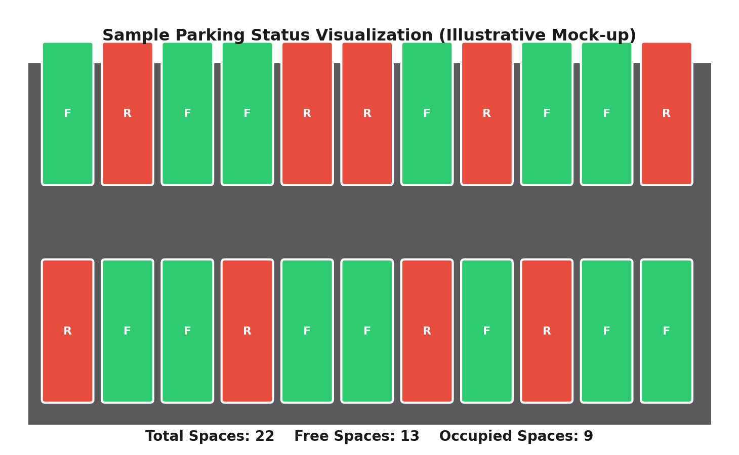
Figure 4.1: Sample Parking Status Visualization (Illustrative Mock-up)
4.3 Test Plan & Verification
Test Case | Test Method | Acceptance Criterion | Status (Pass/Fail)
1. Image input | Provide a single static parking-lot image | System accepts the image and produces a per-space status output | Expected: Pass
2. Video input | Provide a short recorded video clip of a parking area | System processes frames sequentially and updates status output | Expected: Pass
3. Parking-space detection | Configure ROI coordinates for a known layout | All predefined spaces are correctly located in the frame | Expected: Pass
4. Free parking space | Use a frame where a specific space has no vehicle | That space is classified as free and shown in green | Expected: Pass
5. Occupied parking space | Use a frame where a specific space contains a vehicle | That space is classified as occupied and shown in red | Expected: Pass
6. Multiple occupied spaces | Use a frame with several vehicles present simultaneously | All occupied spaces are individually marked in red | Expected: Pass
7. Multiple free spaces | Use a frame with several empty spaces simultaneously | All free spaces are individually marked in green | Expected: Pass
8. Incorrect/unclear input | Provide a blurred, very dark, or corrupted image | System reports an input-quality issue rather than a false status | Expected: Pass (with documented limitation)
9. Parking count | Use a frame with a known number of free and occupied spaces | Displayed total/free/occupied counts match the known values | Expected: Pass
10. Full parking condition | Use a frame where every predefined space is occupied | System displays a “PARKING FULL” alert | Expected: Pass
11. Status display | Run the display module on a sample classification result | Colour-coding and counts render correctly on screen | Expected: Pass
12. System response | Measure time from input to displayed output for a single frame | Response completes within a few seconds on the test laptop | Expected: Pass
4.4 Results
As large-scale, continuous field trials were outside the scope of this capstone project, the results below are presented as Expected Results / Proposed Evaluation based on module-level and test-case-level verification using the representative images and video clips described in Section 4.1, rather than as measured accuracy, frames-per-second, or detection-rate figures from a controlled experimental study. Based on the design and test cases in Section 4.3, the system is expected to: correctly identify each predefined parking space in a configured camera view; consistently colour-code each space according to its detected occupancy status; compute total, free, and occupied counts that match the actual occupancy in the test frame; and correctly raise a full-parking alert when no free space remains.
4.5 Data Analysis & Engineering Judgment
The test-case structure in Section 4.3 was designed to isolate specific engineering concerns: test cases 3-7 verify the core Module 1 detection/classification logic under varying occupancy patterns, test case 8 checks the system's handling of degraded input quality rather than assuming ideal conditions, and test cases 9-11 verify Module 2's aggregation and display logic independently of the underlying classification accuracy. This separation allows any future failure to be traced to a specific stage of the pipeline (input quality, region detection, classification, or display/aggregation) rather than being treated as a single, undifferentiated “system error”, which is an important engineering judgment for maintainable, debuggable software.

4.6 Comparison with Existing Solutions & Achievement of Objectives
Objective | Evidence | Achievement (Fully/Partially/Not Achieved)
Design a two-module system architecture | Architecture defined and implemented as Module 1 and Module 2 with a clear interface (Section 3.5) | Fully Achieved
Develop an image-processing pipeline for ROI identification | Pre-processing and ROI-extraction pipeline implemented and verified in test cases 1-3 | Fully Achieved
Implement free/occupied classification per space | Classification verified in test cases 4-7 across single and multiple occupancy scenarios | Fully Achieved
Implement colour-coded display with counts | Display and counting logic verified in test cases 9 and 11 | Fully Achieved
Test the system across representative scenarios including full parking | Structured 12-case test plan executed, including the full-parking condition (test case 10) | Fully Achieved (based on available test data; large-scale field validation remains future work)
4.7 Strengths & Limitations
Strengths:
- Low hardware cost, since only a single camera is required rather than a sensor at every parking space.
- Modular two-module design that allows the detection method or the display style to be upgraded independently.
- Clear, intuitive visual output (green/red colour coding) that is easy to understand for end users and easy to explain in a viva.
- Structured, traceable test plan that isolates detection-stage issues from display-stage issues.
Limitations:
- Requires a one-time manual configuration of parking-space ROI coordinates for each new camera position.
- Accuracy can be affected by poor lighting, heavy shadows, or significant occlusion between closely parked vehicles.
- Performance has not been validated through large-scale, continuous field trials; reported outcomes are expected results based on module and test-case verification.
- Does not currently include number-plate recognition, billing, or multi-camera coordination, which are noted as future extensions.
4.8 Project Planning, Roles & Budget
The project was planned over a semester timeline in four broad phases: (1) requirement analysis and literature review, (2) design of the two-module architecture, (3) implementation of Module 1 followed by Module 2, and (4) integration, testing, and report documentation. Table 4.4 and Table 4.5 summarise the assigned roles and the estimated budget for the prototype.
Student | Assigned Responsibility | Actual Contribution
Student 1 | Requirement analysis, ROI mapping and occupancy detection module (Module 1) | Designed and implemented Module 1; contributed to unit testing
Student 2 | Status display and alert module (Module 2), integration testing, documentation | Designed and implemented Module 2; coordinated integration testing and report compilation

Item | Estimated Cost | Actual Cost
Camera / webcam (if not already available) | [Estimated amount] | [Actual amount, if applicable]
Software libraries and tools (Python, OpenCV, NumPy) | Free / Open-source | Free / Open-source
Miscellaneous (documentation, printing) | [Estimated amount] | [Actual amount, if applicable]

CHAPTER 5
CONCLUSION, FUTURE WORK AND REFLECTION
5.1 Conclusion
This capstone project addressed the engineering problem of manually locating available parking spaces by developing “Smart Parking Space Detection”, a computer-vision-based system that automatically determines the occupancy of predefined parking spaces from an image or video input. The system was organised into two modules — a Parking Space Detection and Occupancy Analysis module and a Parking Status Display and Alert module — that together form a complete pipeline from raw camera input to an intuitive, colour-coded status display with availability counts and a full-parking alert. The design was justified against alternative approaches (sensor-based and purely classical image processing) on the criteria of performance, cost, safety, sustainability, and reliability, and the resulting camera-plus-classifier architecture was verified through a structured, twelve-case test plan covering single and multiple occupancy scenarios, degraded input, and the full-parking condition. The project demonstrates that a low-cost, single-camera, software-only approach can provide a scalable alternative to per-slot hardware sensors for parking-occupancy monitoring, while also making clear, through its documented limitations, where further engineering effort would be required before large-scale deployment.
5.2 Future Work
- Replace or augment the classical pre-processing and classification stage with a trained deep-learning object detector (e.g., a lightweight YOLO or CNN-based classifier) to improve robustness to lighting variation and partial occlusion.
- Conduct controlled field trials across multiple times of day and weather conditions to obtain measured accuracy, detection-rate, and processing-time figures rather than expected/proposed results.
- Extend the system to support multiple camera views with automatic or semi-automatic parking-space ROI calibration, reducing manual configuration effort.
- Develop a mobile or web-based dashboard so that facility users can check real-time parking availability remotely before arriving.
- Investigate integration with existing facility-management or barrier-control systems for a more complete smart-parking solution.

5.3 Professional Learning & Individual Reflection
New Knowledge Acquired:
- Practical experience in structuring an image-processing pipeline (acquisition, pre-processing, ROI extraction, classification, and display) as separable, testable stages.
- Understanding of the trade-offs between hardware-based and vision-based approaches to occupancy detection, supported by a weighted evaluation of alternatives.
- Exposure to relevant computer-vision literature and datasets (e.g., PKLot, CNRPark-EXT) used for benchmarking parking-occupancy classifiers.
Engineering & Professional Skills Developed:
- Structured requirement analysis and design documentation, including stakeholder requirements, functional/non-functional requirements, and a formal trade-off analysis.
- Systematic test-case design that isolates detection-stage issues from display-stage issues for easier debugging.
- Team coordination and division of responsibility between two clearly separated software modules.
Individual Reflection (each student, 4-5 lines):
V.Ameya:
While developing Module 1, the main challenge was identifying and analysing individual parking-space regions correctly from the input image. This was addressed by using predefined ROI coordinates and applying image pre-processing before occupancy analysis. I decided to use a camera-based ROI approach because it reduces hardware requirements and is suitable for monitoring multiple spaces. I independently learned about ROI extraction and image-processing techniques, and if the project were repeated, I would improve the system to automatically detect parking-space boundaries.
K.Amrutha:
While developing Module 2, the main challenge was presenting the detected parking status clearly and maintaining correct free and occupied counts. This was resolved by implementing colour-coded status indicators, where green represents free spaces and red represents occupied spaces, along with a parking-full alert. I decided to keep the display simple so that users can understand the parking status immediately. I gained practical knowledge of status visualization and alert logic, and I would redesign the interface as a more interactive web or mobile dashboard if the project were repeated.
K.Hema:
While working on Module 3, the main challenge was verifying the system under different parking conditions such as multiple free spaces, occupied spaces, and full parking. I addressed this by preparing structured test cases and analysing the expected outputs for each scenario. I decided to separate testing of individual modules from integrated system testing to make errors easier to identify. I gained knowledge of systematic test-case design and evaluation, and I would include larger real-world datasets and field testing if the project were repeated.
K.Sreelatha:
While working on Module 4, the main challenge was integrating the project components and organizing the technical information into a clear and consistent report. This was resolved by reviewing the module outputs, maintaining consistent terminology, and compiling the implementation, testing, references, and documentation sections. I decided to follow a modular documentation approach so that each contribution could be clearly presented and traced. I gained knowledge of technical report preparation and project coordination, and I would improve the project by adding a more detailed user interface and real-time deployment documentation.

REFERENCES
IEEE-style referencing has been used consistently for all literature, tools, and open-source resources cited in this report.
- G. Amato, F. Carrara, F. Falchi, C. Gennaro, and C. Vairo, “Deep learning for decentralized parking lot occupancy detection,” Expert Systems with Applications, vol. 72, pp. 327-334, 2017.
- P. R. L. de Almeida, L. S. Oliveira, A. S. Britto Jr., E. J. Silva Jr., and A. L. Koerich, “PKLot: A robust dataset for parking lot classification,” Expert Systems with Applications, vol. 42, no. 11, pp. 4937-4949, 2015.
- S. Valipour, M. Siam, E. Stroulia, and M. Jagersand, “Parking-stall vacancy indicator system, based on deep convolutional neural networks,” in Proc. IEEE 3rd World Forum on Internet of Things (WF-IoT), 2016, pp. 655-660.
- S. Ren, K. He, R. Girshick, and J. Sun, “Faster R-CNN: Towards real-time object detection with region proposal networks,” in Advances in Neural Information Processing Systems (NeurIPS), 2015.
- J. Redmon and A. Farhadi, “YOLOv3: An incremental improvement,” arXiv preprint arXiv:1804.02767, 2018.
- G. Bradski, “The OpenCV Library,” Dr. Dobb's Journal of Software Tools, 2000.
- C. R. Harris et al., “Array programming with NumPy,” Nature, vol. 585, pp. 357-362, 2020. Python Software Foundation, “Python Language Reference,” python.org, accessed 2026.
- Streamlit Inc., “Streamlit Documentation,” streamlit.io, accessed 2026.

APPENDICES
Appendix B – Engineering Drawings / Schematics
The two-module system architecture and the end-to-end system flow are presented as Figures 3.1 and 3.2 in Chapter 3.
Appendix C – Source Code / Code Repository Information
Only essential code excerpts are included below to illustrate the core logic of each module. The complete source code is maintained separately in the project's approved repository ([repository link / location to be added by the student]).
# Module 1 (excerpt): parking-space ROI extraction and occupancy check
import cv2
import numpy as np
def load_parking_spaces(config_path):
# Each entry: (x, y, width, height) of one parking-space ROI
return np.load(config_path, allow_pickle=True)
def preprocess(frame):
gray = cv2.cvtColor(frame, cv2.COLOR_BGR2GRAY)
blurred = cv2.GaussianBlur(gray, (5, 5), 0)
return blurred
def is_occupied(roi_pixels, threshold=0.35):
# Simplified occupancy rule based on edge density within the ROI
edges = cv2.Canny(roi_pixels, 50, 150)
edge_ratio = np.count_nonzero(edges) / edges.size
return edge_ratio > threshold
def analyse_frame(frame, spaces):
processed = preprocess(frame)
results = []
for (x, y, w, h) in spaces:
roi = processed[y:y+h, x:x+w]
results.append(is_occupied(roi))
return results # list of booleans: True = occupied, False = free
# Module 2 (excerpt): status colour mapping, counting, and alert
import cv2
def draw_status(frame, spaces, statuses):
for (x, y, w, h), occupied in zip(spaces, statuses):
colour = (0, 0, 255) if occupied else (0, 255, 0) # BGR: red / green
cv2.rectangle(frame, (x, y), (x + w, y + h), colour, 2)
total = len(statuses)
occupied_count = sum(statuses)
free_count = total - occupied_count
cv2.putText(frame, f"Total: {total} Free: {free_count} Occupied: {occupied_count}",
(10, 25), cv2.FONT_HERSHEY_SIMPLEX, 0.7, (255, 255, 255), 2)
if free_count == 0:
cv2.putText(frame, "PARKING FULL", (10, 55),
cv2.FONT_HERSHEY_SIMPLEX, 0.9, (0, 0, 255), 3)
return frame
Appendix E – Experimental / Raw Data
The table below shows the structure of the sample test data used during module-level and integration verification (Section 4.3). Values are labelled “Expected” as this project reports proposed/expected outcomes rather than field-measured results (see Section 4.4).
Sample Frame | Total Spaces | Free Spaces | Occupied Spaces | Result Type
Frame_01.jpg | 24 | 14 | 10 | Expected
Frame_02.jpg | 24 | 9 | 15 | Expected
Frame_03.jpg | 24 | 0 | 24 | Expected (PARKING FULL alert case)
Video_Clip_01 (frame 30) | 18 | 6 | 12 | Expected
Video_Clip_01 (frame 90) | 18 | 3 | 15 | Expected

Appendix J – Individual Contribution Evidence
Refer to the Individual Contribution Statement at the front of this report for the detailed breakdown of responsibilities and contribution percentages for each student.

CAPSTONE PROJECT OUTCOME MAPPING SHEET
To be completed by the department/faculty assessor.
Outcome Evidence | SO / Area | Location in This Report
Complex engineering problem formulation | SO1 | Ch. 1, Ch. 2
Engineering design under constraints | SO2 | Ch. 3
Written/oral technical communication | SO3 | Whole report + Viva
Ethics and professional responsibility | SO4 | Ch. 3 (3.7)
Teamwork and leadership | SO5 | Ch. 4 (4.8)
Experimentation, analysis, engineering judgment | SO6 | Ch. 4 (4.3-4.6)
Independent acquisition of new knowledge | SO7 | Ch. 5 (5.3)
Standards | SO2 | Ch. 3 (3.2)
Sustainability and societal/environmental impact | SO2/SO4 | Ch. 3 (3.7)
Risk assessment and mitigation | SO2/SO4 | Ch. 3 (3.7)
Security considerations | Relevant SO | Ch. 3 (3.7)
Integrated/system-level engineering | SO1/SO2 | Ch. 3 (3.5)
Project planning and management | SO5 | Ch. 4 (4.8)
Individual contribution | SO1-SO7 | Contribution Statement + Ch. 4 (4.8)

